**I смена**

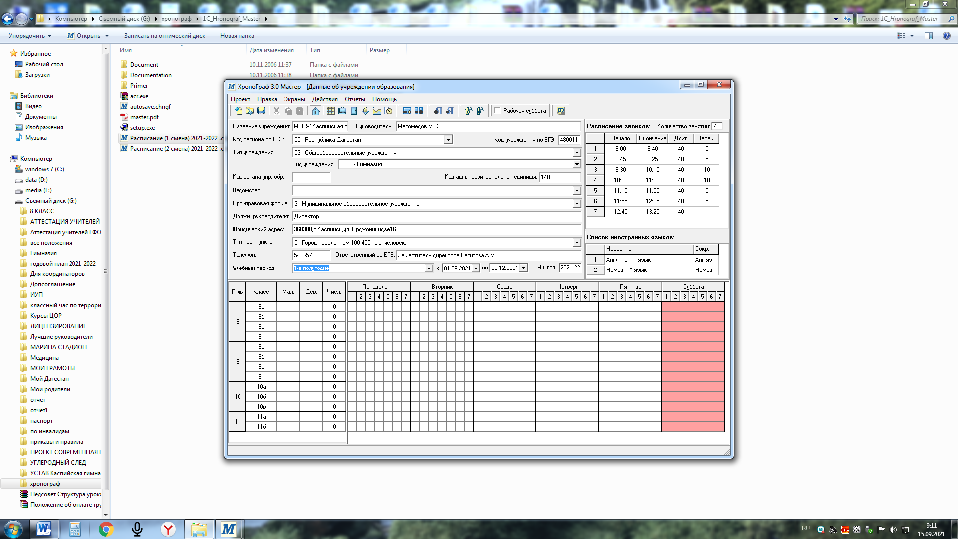**_________________________________________________________________________________________**

**II смена**

